GitHub – Cloning Repository

T Godwin Abilash – 192321012

**Set Up Git**

* Install [Git](https://git-scm.com/downloads) on your system if not already installed.
* Configure Git with your username and email:

git config --global user.name "Your Name"

git config --global user.email "youremail@example.com"

git init

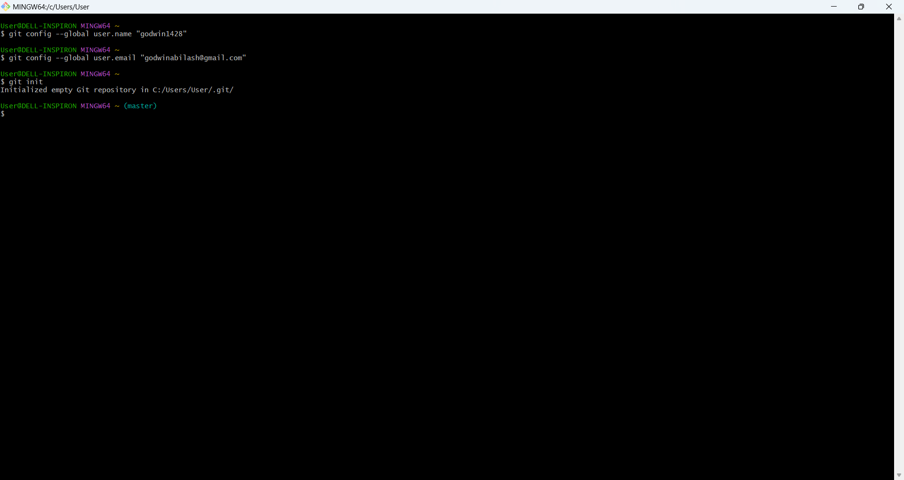

1. Choose an Existing GitHub Repository

1. Visit a public repository on GitHub
2. Copy the repository's HTTPS URL:
   * On the repository page, click the green "Code" button and copy the URL (e.g., https://github.com/octocat/Hello-World.git).

2. Clone the Repository

1. Open a terminal/command prompt.
2. Navigate to the directory where you want to clone the repository:

cd demose

1. Clone the repository:

git clone https://github.com/octocat/Hello-World.git

1. Navigate into the cloned repository directory:

cd sepractical

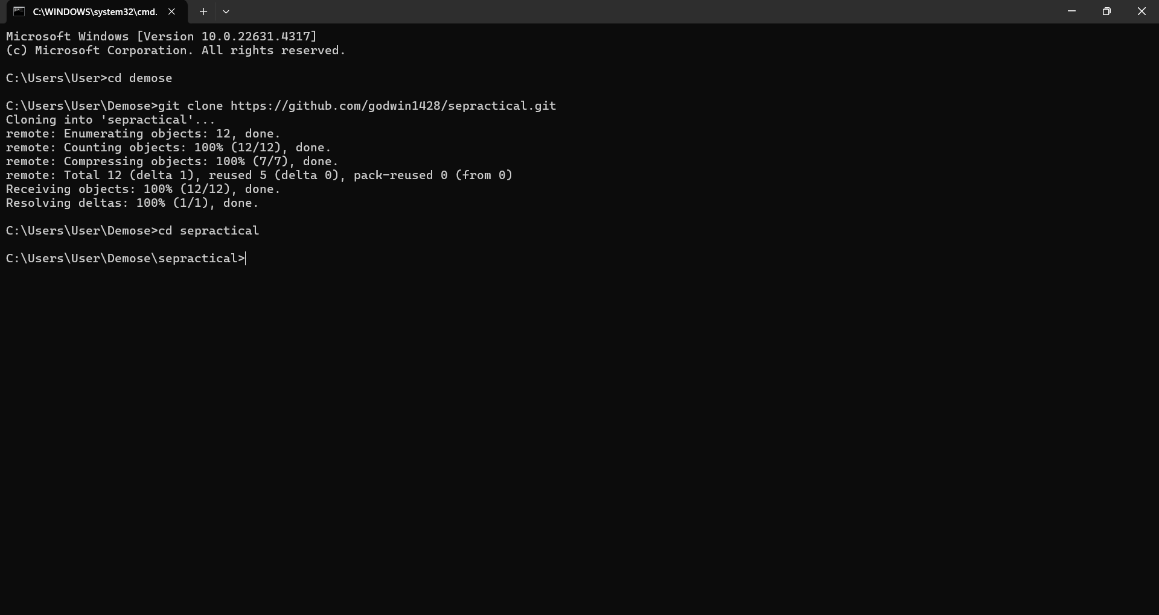

3. Make a Small Change

1. Open one of the files in the repository using a text editor or IDE. For example:

nano README.md

1. Make a small edit, such as adding a new line:

# Hello-World This is a sample project. Edited for testing purposes.

1. Save and close the file.

4. Verify the Changes

1. Check the status of the repository to confirm the change:

git status

The modified file will appear in the list of changed files.

